 COSC 1320
B12
Thanh Vo
Name: _________________ Seat # __

Estimated Hours 1
Actual Hours
1

TA (Textual Analysis) for UML USE CASE Diagram MODEL
Programming Assignment 4:
(10 points)
(Due date found in the COSC 1320 BB Calendar!)
You must use Microsoft WORD program. Insert the TEMPLATEs for Actors and Use Cases in this Requirements Document.

Please have Step 1, 2, 3, and 4 in this order.

PLEASE use the “TA for UML USE CASE Diagram MODEL Movie Company System.doc” AS TEMPLATE.
(Do not Show STEP 1,…; do not change Line Numbers; do not change Number of Pages)

Any DIAGRAM that is NOT the result of CUT and PASTE
WILL BE IGNORED. (YOU WILL GET ZERO POINTS)
Requirements Analysis: Construct the UML USE CASE Diagram MODEL
A1: User
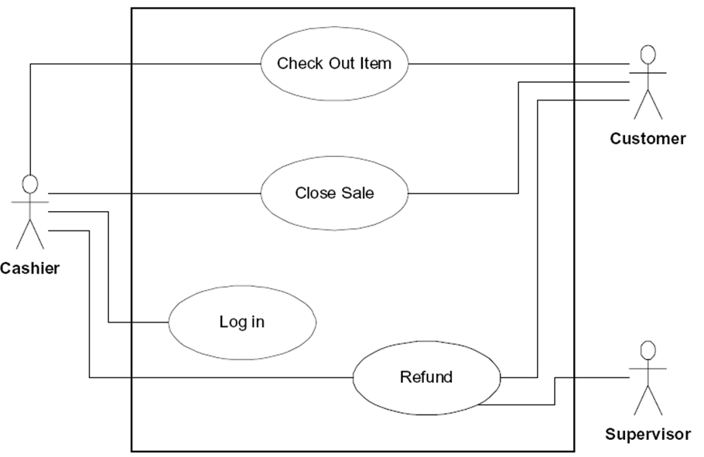
ProgrammingAssignment4 software product for a Video Store

For a family or an individual, a favorite place to go on weekends or holidays is to a video store to rent movies. A new video store in your neighborhood is about to open. However, it does not have a program to keep track of its videos and customers. The store managers want someone to write a program for their system so that the video store can function. The program should be able to perform the following operations:
UC2: UCDisplayVideos
UC1: UCLoad
UC8: UCSave
1. Display a list of all of the videos in the store (full information).
2. Search a video - by title and show the details of a particular video (title, stars (up to two!), producer, director, productioncompany, copiesinstock).
UC3: UCSearchVideo
UC4: UCRentVideo
3. Rent a video.
4. Display a list of all of the store’s customers (full information).
UC5: UCDisplayCustomers

5. Search a customer by name and display the details of a particular customer – by last name (firstname, lastname, id).
UC6: UCSearchCustomer
6. Display a list of all of the videos rented by a particular customer – by last name (firstname, lastname, title, title).
UC7: UCDisplayRentedVideo

ProgrammingAssignment4 should illustrate the Object Oriented Paradigm methodology and, in particular, inheritance and overloading.

There is a need to maintain the following lists (cannot use STL Classes):
A list of all of the videos in the store
A list of all of the store’s customers
Lists of the videos currently rented by the customers

Provide member functions to load the video store collection, customer information & customer rental information from the file “Programming Assignment 4 Data.txt” (FILE INPUT) into your ProgrammingAssignment4 APPLICATION memory (please DO NOT read from File and write to File skipping reading into the program memory) and write it back out to the SAME data file (FILE OUTPUT) when exiting from ProgrammingAssignment4 APPLICATION “Programming Assignment 4 Data.txt”.

The data in the input file “Programming Assignment 4 Data.txt” is in the following format:

number of videos
video title ( that is, the name of the movie)
movie star1
movie star2
movie producer
movie director
movie production co.
number of copies
. . .
Customer’s first name,last name,and id
. . .
Customer id,video title,video title
A sample input file “Programming Assignment 4 Data.txt” follows:

3
Titanic
Kate Winslet
Leonardo DiCaprio
Cameron
Cameron
20th Century Fox
2
Jerry MacGuire
Tom Cruise
Renne Zellwegger
Brooks
Crowe
United Artists
18
Rain Man
Dustin Hoffman
Tom Cruise
Johnson
Levinson
United Artists
2
Donald,Duck,1
Mickey,Mouse,2
Minnie,Mouse,3
Goofy,Dog,4
4,Rain Man,Titanic
1,Jerry MacGuire

Create a ProgrammingAssignment4.cpp that contains the main ().

Classes must start with UpperCase Letter.
Classes must have .h and .cpp.
One Class per File Name that matches the Class Name.

You cannot use any DATA STRUCTURES STL Classes! Use arrays.
One Class per .h &.cpp file (you will lose 15 points if not)!
Must use Inheritance (you will lose 20 points if not)!
Each Class MUST HAVE a toString() member function(you will lose 20 points if not)!
Is toString() member function used to display customers, videos, or rented videos by customer (you will lose 10 points if not)!

Each .h & .cpp file must have these 4 lines of comments (you will lose 5 points if not):
// COSC 1320 Summer 2015
// Name:
// Programming Assignment 4
// This is my own work; I will not post

Controller
A1: User
UCLoad

UC 1

UC2

UC3

UC4

UC5

UC6

UC7

UC8

UCDisplayVideos
UCSearchVideo
UCRentVideo
UCDisplayCustomers
UCSearchCustomer
UCDisplayRentedVideos
UCSave
Controller
UC1 UCLoad Description
Name: | UC1: UCLoad
Actor: | none
Description: | This use case interprets a process which program opens a text file then streams in the data sets for video, customer and rented video
Successful Completion: | User starts the program. The program finds the directory path to the text file and opens it. All information required for the program in the text file is streamed in and assigned to appropriate variables. After finished, the program closes the text file
Alternative | If there is no text file in the same directory as the program, the program will give notification for no text file found then exit immediately
Pre-condition: | The member variables for each class and for the counters is empty
Post-condition: | The member variables for each class are filled with the information streamed in from text file successfully. The member variable for counters is filled with number of data sets appeared in each class
Assumptions: | None

UC2 UCDisplayVideos Description
Name: | UC2: UCDisplayVideos
Actor: | User
Description: | This use case interprets a process which program display a list of videos
Successful Completion: | User chooses the first option, the program displays the data sets of videos that is currently in this video store
Alternative | none
Pre-condition: | Current data sets of videos
Post-condition: | Output to screen current data sets of videos
Assumptions: | None

UC3 UCSearchVideo Description
Name: | UC3: UCSearchVideo
Actor: | User
Description: | This use case interprets a process which program search the video title input from User in video list and display the data set containing this title
Successful Completion: | User chooses second option, the program asks for User input of title. The program search for this title in the array video. If there is any title that matches, the program will display the data set containing this title. If not, the program will show a notification
Alternative | none
Pre-condition: | Current data sets of videos
Post-condition: | The data set containing the video title of User input or the notification of no video found will display on the screen
Assumptions: | None

UC4 UCRentVideo Description
Name: | UC4: UCRentVideo
Actor: | User
Description: | This use case interprets a process which program add a new data set to customer list and rented video list
Successful Completion: | User chooses third option, the program asks for User input of last name and first name. Program sets these data to new data set in customer list. ID increases by 1 and set to ID of this set. Program asks for User input of video title 1 then searchs for it in video list, if found, set that title for video title 1 in the new data set of rented video list, else, output not-found message. Program asks User if they want another. If yes, program asks User for video title 2 and do same thing as video title 1. However, User can only rent 2 videos so if the video title 2 is found in the video list, this use case ends. On the other hand, this use case can end if User hit N for the answer of wanting another video
Alternative | none
Pre-condition: | Current data sets of customers and rented videos and videos
Post-condition: | The data sets of customers and rented videos increases by 1
Assumptions: | None

UC5 UCDisplayCustomers Description
Name: | UC5: UCDisplayCustomers
Actor: | User
Description: | This use case interprets a process which program display a list of customers
Successful Completion: | User chooses the fourth option, the program displays the data sets of customers that are currently renters in this video store
Alternative | none
Pre-condition: | Current data sets of customers
Post-condition: | Output to screen current data sets of customers
Assumptions: | None

UC6 UCSearchCustomer Description
Name: | UC6: UCSearchCustomer
Actor: | User
Description: | This use case interprets a process which program search the customer’s last name input from User in customer list and display the data sets containing this last name
Successful Completion: | User chooses fifth option, the program asks for User input of last name. The program searchs for this last name in the array customer. If there are any last names that match, the program will display the data sets containing these last names. If not, the data will show a notification
Alternative | None
Pre-condition: | Current data sets of customers
Post-condition: | The data sets containing the last name of User input or the notification of no customer found will display on the screen
Assumptions: | None

UC7 UCDisplayRentedVideos Description
Name: | UC7: UCDisplayRentedVideos
Actor: | User
Description: | This use case interprets a process which program display a list of rented videos
Successful Completion: | User chooses the sixth option, the program displays the data sets of rented videos that is currently in this video store
Alternative | none
Pre-condition: | Current data sets of rented videos
Post-condition: | Output to screen current data sets of rented videos
Assumptions: | None

UC8 UCSave Description
Name: | UC8: UCSave
Actor: | None
Description: | This use case interprets a process which program opens a text file then streams out the data sets for video, customer and rented video
Successful Completion: | User chooses to exit the program. The program finds the directory path to the text file and opens it. All data sets of video, customer and rented video are streamed out to the text file. After finished, the program closes the text file
Alternative | If there is no text file in the same directory as the program, the program will give notification for no text file found and exit the program immediately
Pre-condition: | Current arrays for each class (video, customer and rentedVideo) with current data sets
Post-condition: | Current arrays for each class (video, customer and rentedVideo) with current data sets are listed in the text file following the order of video, then customer, then rented video successfully or unsuccessfully
Assumptions: | None

